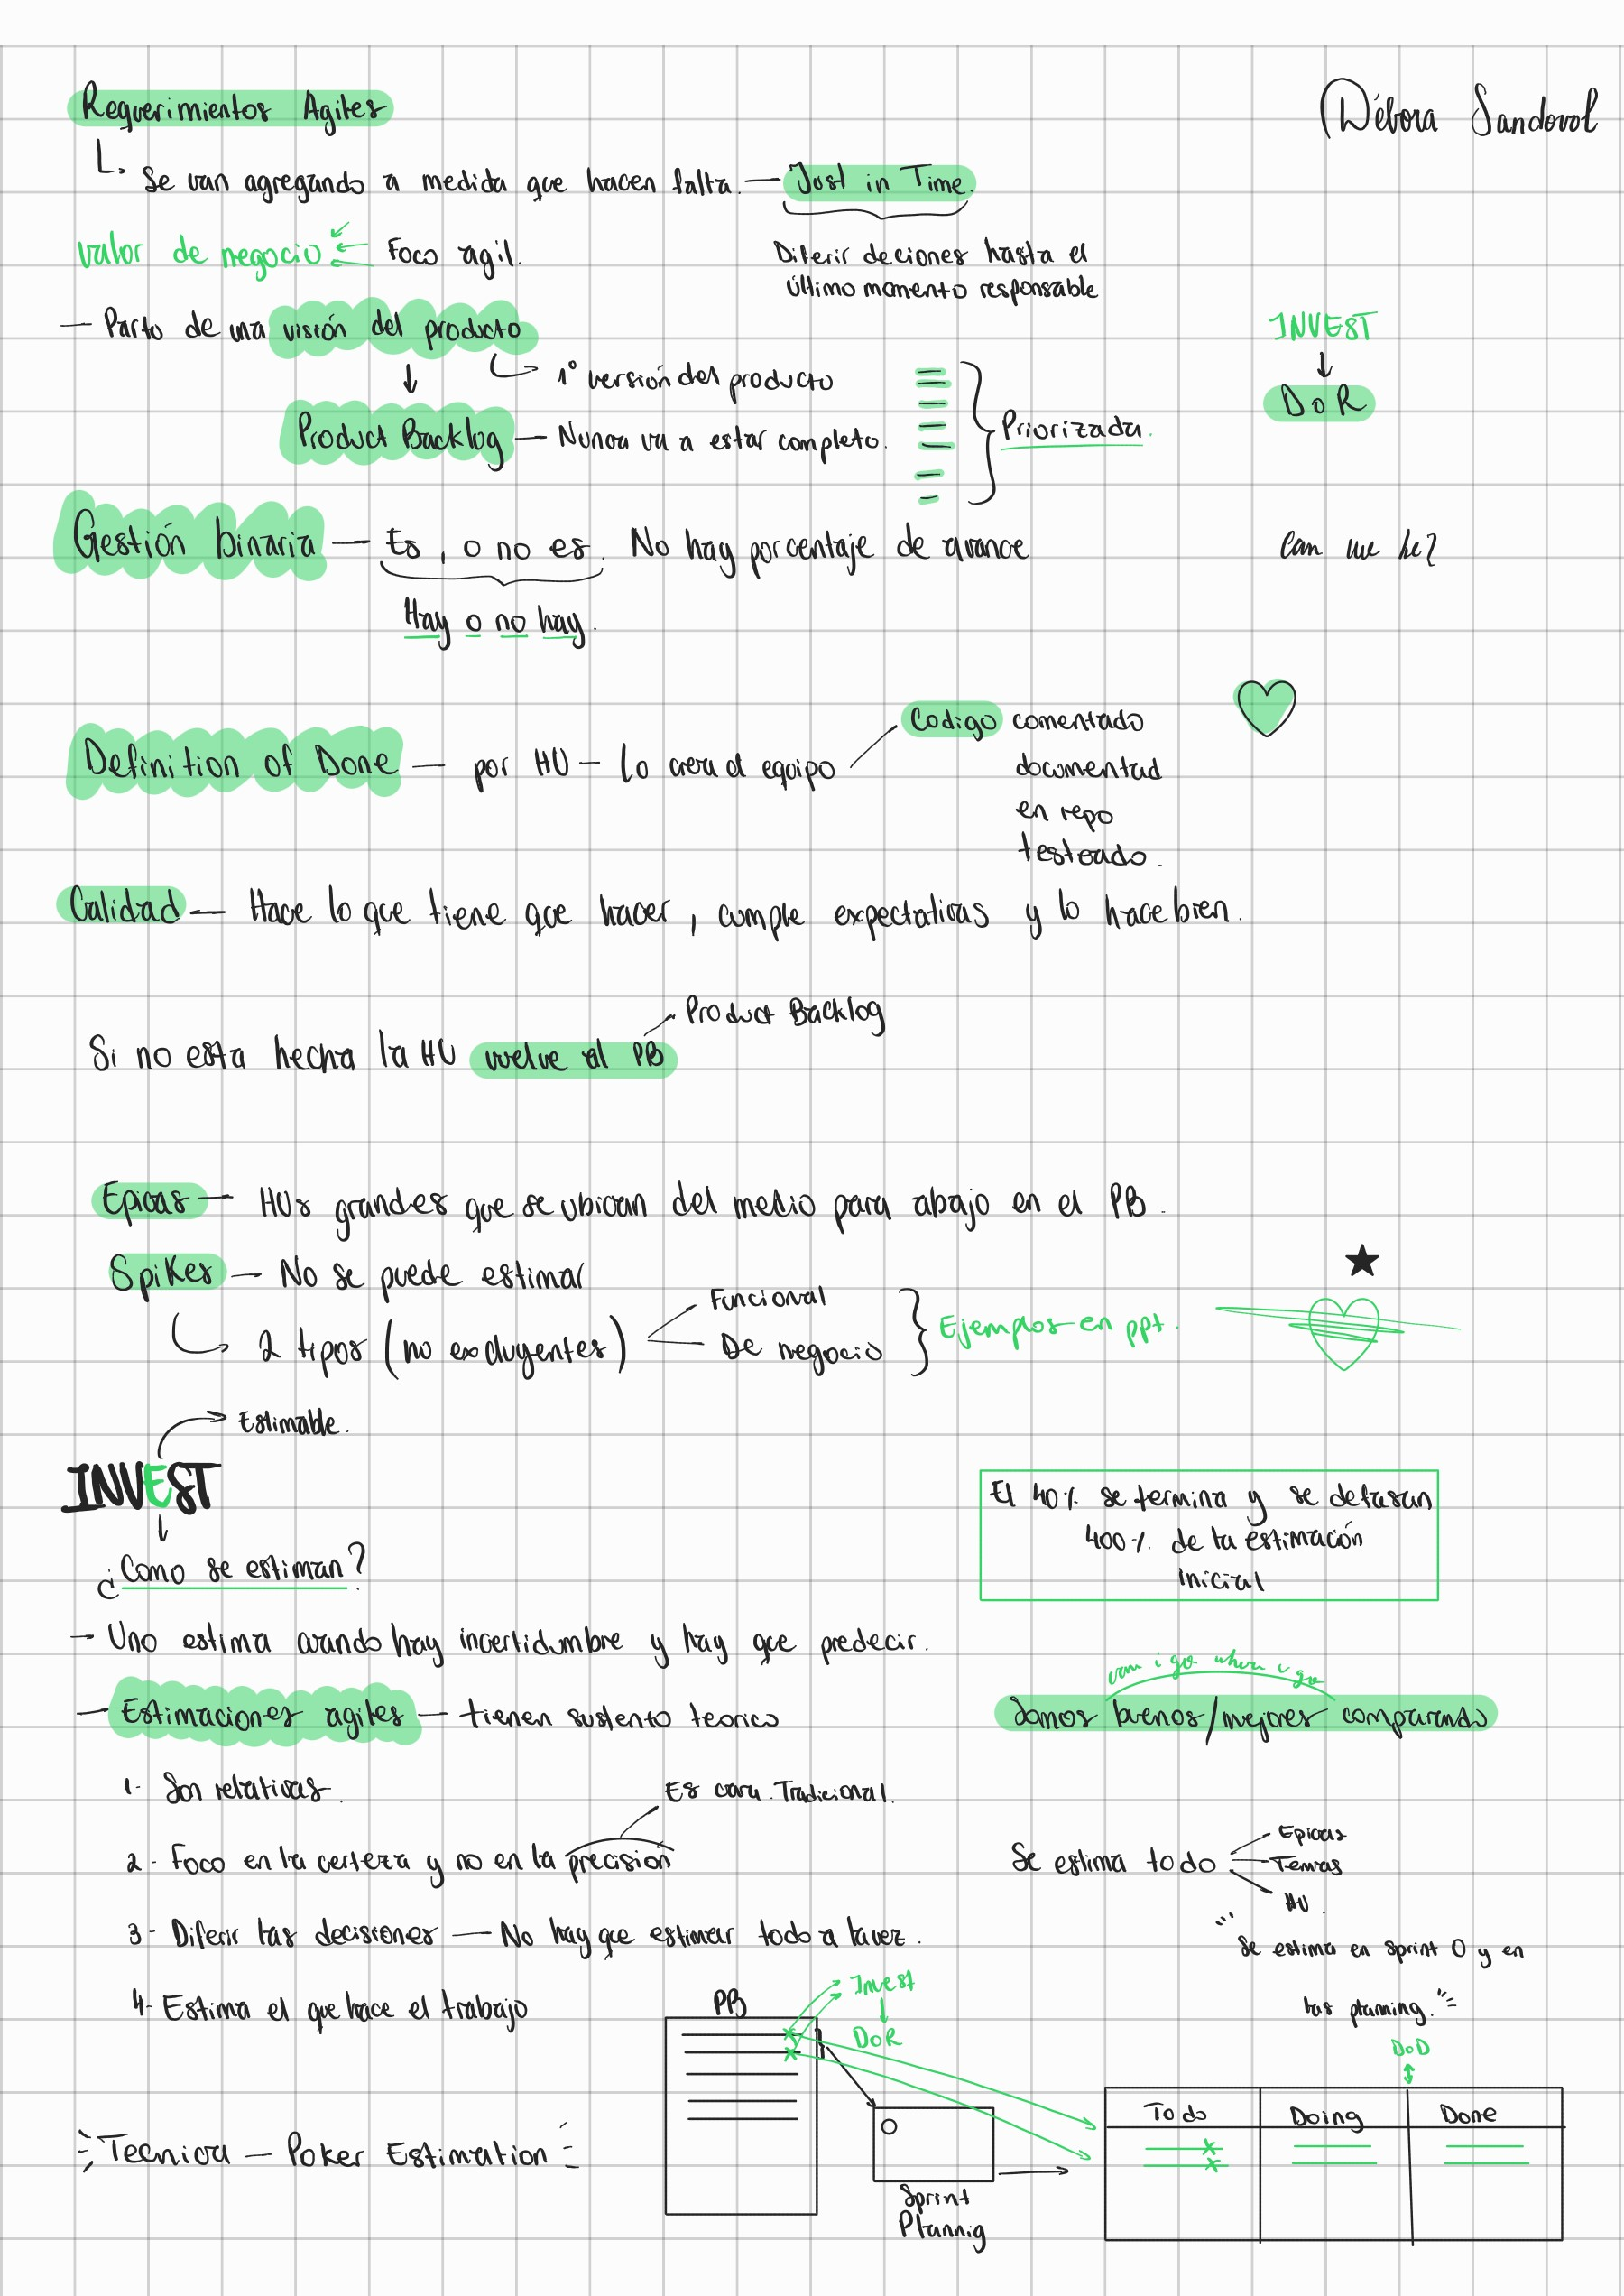

8ΑΊ
iboaq
&καοαωυ
όι
Ι.0Λ
aaaaaaaaaaaaaaaaaaaaoa aaaaaaaaaaaaaaaaaaaaaa aaaaaaaaaaaaaaaaaaaaaa aaaaaaaaaaaaaaaaaaaaaa aaaaaaaaaaaaaaaaaaaaaa aaaaaaaaaaaaaaaaaaaaaa aaaaaaaaaaaaaaaaaaaaaa
aaaaaaaaaaaaaaaaaaaaoa aaaaaaaaaaaaaaaaaaaaaa aaaaaaaaaaaaaaaaaaaaaa aaaaaaaaaaaaaaaaaaaaaa aaaaaaaaaaaaaaaaaaaaaa aaaaaaaaaaaaaaaaaaaaaa aaaaaaaaaaaaaaaaaaaaaa

